Predator diet shifts in the southern Gulf of St Lawrence: evidence for trophic reorganization between the mid-2000s and the late 2010s
A framework to investigate trophic reorganization in marine systems using predator stomach contents
Fisheries and Oceans Canada (DFO), Gulf Region, Moncton, New Brunswick, Canada
Corresponding author: Sosthene.Akia@dfo-mpo.gc.ca

Abstract
The southern Gulf of St Lawrence has changed markedly over three decades, but separating genuine trophic reorganization from ordinary year-to-year variation in fish diets has not been done across the fish community. We analysed stomach contents from 40 demersal and pelagic fish sampled by the DFO September bottom-trawl survey, at three nested spatial scales. For each predator cell we decomposed diet change into three signals: prey diversity, niche breadth, and composition. Their significance was mapped onto four families: Stability, Substitution, Functional change, and Reorganisation. The same framework was applied to five contrasts, three within a decade and two between, so each regime signal could be read against its own short-term variability, across about 100 prey taxonomic resolutions and two currencies (biomass and frequency of occurrence). Within decades, diets were mostly stable (35-62% Stability), with Substitution the leading non-stable outcome. Between decades the distribution inverted: Stability fell to 6-8% and the cells moved almost entirely into the two turnover families, the leading one set by currency, Substitution in biomass (47.0%, with Reorganisation at 40.7%) and Reorganisation in occurrence (49.0%, with Substitution at 41.4%). The signal was Gulf-wide but spatially graded, strongest in the most heavily sampled ecoregions and strata, and consistent across both currencies. The dominant inter-decade signature is therefore a broad turnover in prey identities, often expressed as like-for-like substitution rather than as a loss of dietary diversity, a form of trophic reorganization that conventional functional-group analysis would miss.
Keywords: dietary diversity, PERMANOVA, prey substitution, spatial scale dependence, ecosystem change, trophic indicators

1. Introduction
The southern Gulf of St Lawrence (sGSL) is a shallow, semi-enclosed shelf sea with seasonal ice cover (Galbraith et al., 2021). The marine ecosystem has been monitored since 1971 through a standardized research-vessel bottom-trawl survey carried out each September. This survey provides a fisheries-independent record of the organisms the trawl captures (Hurlbut and Clay, 1990) and provides a uniquely long, consistent baseline against which change can be read.
The sGSL has changed against that baseline. For example, trawlable biomass fell sharply and did not recover over the three decades following the survey’s inception, with little compensatory rise in small fish and invertebrates (Burbank et al., 2025). Several large demersal fishes collapsed and have failed to recover. Atlantic cod (Gadus morhua) collapsed in the early 1990s and has continued to decline despite fishing mortality remaining below sustainable thresholds since (Swain and Chouinard, 2008). White hake (Urophycis tenuis) collapsed and remains depleted after a sharp rise in adult natural mortality through the 1990s (COSEWIC, 2013). American plaice (Hippoglossoides platessoides) declined from the mid-1980s and is now assessed as threatened (COSEWIC, 2009). The two dominant skates declined steeply: thorny skate (Amblyraja radiata) by roughly 95% in adult abundance since 1971, and winter skate (Leucoraja ocellata) by about 98% since 1980, with the latter now near extirpation through elevated adult mortality (Swain et al., 2013, 2009, 2005). However, in the deeper Gulf, redfish (Sebastes mentella and S. fasciatus) resurged over the past decade on exceptional 2011-2013 year classes (Senay et al., 2021)., the reopened redfish Unit 1 fishery (DFO, 2024), that overlaps the sGSL in the Northwest Atlantic Fisheries Organization (NAFO) Division 4T, adds fishing mortality to an already-depleted white hake stock (Rolland et al., 2022)..
Community indicators also show that the sGSL has changed, and roughly by how much (Benoît et al. 2026). Temperatures have increased throughout the water column, while sea ice volume has decreased. These and other environmental changes have been met with ecosystem-level responses. For example, zooplankton diversity has shifted from large, lipid-rick copepods to smaller taxa, leading to a decline in overall zooplankton biomass, and declines in size and condition occur in many demersal taxa. As part of these broader ecosystem studies,

stomachs were collected sporadically from a subset of all marine fishes during the September bottom-trawl survey to examine fish diets.

These collections present an opportunity to examine how the observed community changes are expressed in fish diets, using stomach contents. Each stomach is a record of recent feeding, the combined outcome of prey availability, accessibility, and predator behaviour (Hyslop, 1980), meaning that diet composition is a sensitive signal of trophic change that complements biomass- and community-based measures. Observations of diet composition in the sGSL showed that euphausiids that were a major prey for Atlantic cod through the 1980s had largely been replaced by Atlantic herring by the 1990s, this was interpreted at the time as a major food-web perturbation (Hanson and Chouinard, 2002). Stomach contents of other predators have also been described, as white hake (Hanson, 2011) and a broader set of coastal demersal and pelagic fishes (Hanson, 2018), but only as single-species or static accounts; no prior study tracked change of a community of fish species through time. Whether the community change is mirrored in this community of fish diets, and in what form, is still open.
Diet data are a limited and noisy sample of feeding. A stomach captures only the most recent meals, and that window varies, because gastric evacuation depends on the predator, on temperature, and on prey type (Bromley, 1994; dos Santos and Jobling, 1991). What a stomach holds also depends on when and where the predator was caught. Feeding varies with season (Schwalme and Chouinard, 1999) and among individuals; the survey’s fixed September timing holds the seasonal cycle roughly constant, but the rest remains. Diet reflects locally available prey (Hanson, 2018), so it carries a spatial signature set by how wide are the predator home ranges. Inference also depends on the sampling design: the number of stomachs examined, the diversity of predator species and size classes sampled, and the taxonomic resolution at which prey are classified (Cortés, 1997). A single between-year comparison may come out significant when nothing has been restructured, or be non significant when a change is real but modest. No single contrast can be trusted on its own; a between-decade change is convincing only when it forms a clear, repeated pattern that ordinary year-to-year variation does not reproduce.

Our aim is to ask how the community reorganization documented for the sGSL (Burbank et al., 2025) is written into the diets of selected fish between the mid-2000s and the late 2010s, while separating regime-scale change from ordinary year-to-year variation. We therefore take the predator community-prey community interactions as the unit of study, and as an ecosystem-scale signal. The method aims to document community changes through a diagnostic framework that contrasts within and between each decade. The framework uses 3 indices (i.e. diversity, niche breadth and dissimilarity) to sorts each predator’s diet composition change into interpretable types along a gradient of increasing severity. The gradient range from stability to community reorganisation through multi-indices change (Section 2.3). We test the classification across prey taxonomic resolutions and in two dietary currencies, biomass and frequency of occurrence (Baker et al., 2014).
Three questions structure the analysis. First, within each decade, how diets composition change among predators, and does that differ between the mid-2000s and the late 2010s? Second, how does the diets composition change when the two decades are contrasted directly? Third, is any between-decade signal organized spatially across the sGSL, and consistent across the two currencies? Answering them turns the broad expectation that a reorganized community must feed differently into a specific, testable account of where fish diets changed, how widely, and in what form. The framework could also be transferable to other systems with long-term diet records.

2. Material and methods

2.1 Study area, survey, and diet data
The sGSL includes most of NAFO Division 4T lies south of the Laurentian Channel and is bordered by Quebec, New Brunswick, Nova Scotia and Prince Edward Island. Diet data come from the September research-vessel (RV) bottom-trawl survey. The survey follows a depth-stratified random design covering roughly 20 to 350 m (Hurlbut and Clay, 1990) and is carried out mainly in September, with a few tows in August or October in some years (Figure 1).
Two vessels were used over the period that brackets this study: the CCGS Alfred Needler (2004-2005), and the CCGS Teleost (2006 onward). The change from the Needler to the Teleost in 2006 was calibrated by comparative fishing in 2004-2005 (Benoît, 2006; Benoît and Swain, 2003). The 2004-2005 surveys were made by the Needler and the 2006 survey by the Teleost, whereas the 2018-2019 surveys were made by the Teleost alone.
At each fishing set the catch was processed under standard survey procedures, and a subsample of each focal fish was retained for diet analysis by stratified-random sampling across the length range of the catch. For each predator fish, taxonomic identification and somatic length were recorded before the stomach was excised and frozen. Stomach contents were processed under the standard DFO diet protocol (REF)Each stomach was thawed and its contents identified to the lowest practical taxonomic level following the prey-identification guide of Darcy et al. (2024), and the mass of each prey taxon recorded. Data are organised as one record per prey item, nested within stomach, set, survey and region; set records carry the survey covariates (date, geographic position, depth, bottom temperature, bottom salinity and vessel). Each stomach was assigned to one of four southern-Gulf ecoregions of the Gulf of St. Lawrence Ecosystem Approach (GSLEA) framework (Duplisea et al., 2024, 2020), Baie des Chaleurs, the Northumberland Strait, the Magdalen Shallows and the Central sGSL, according to its capture position (Figure 2).

2.2 Data preparation and contrast design
.. A stomach was counted as empty when all of its records were non-nutritional (i.e. parasites, abiotic material, debris).
Following the principle that diets can be characterized and compared only when each group is adequately sampled (Bizzarro et al., 2007; Ferry and Cailliet, 1996), we required each predator species to have at least 90 stomachs over the whole study and at least 10 in each period compared. Each predator was assigned a size class relative to its length at maturity (juvenile, adult, or a single pooled class) to control for ontogenetic shifts (Scharf et al., 2000). Ecoregions were assigned by a nearest-feature spatial join (R package sf; Pebesma, 2018). The retained data comprised 40 demersal and pelagic fish predators across 59 predator × size-class cells, totaling 11,505 stomachs in 2004-2006 and 4,194 in 2018-2019 (Table S1).
Prey were identified to uneven taxonomic depth, since identifiability declines as digestion progresses (Buckland et al., 2017; Chipps and Garvey, 2007; Hyslop, 1980). Prey names and legacy codes were validated with the World Register of Marine Species (WoRMS Editorial Board, 2023) using the R packages worms (Chamberlain and Vanhoorne, 2023) and taxize (Chamberlain and Szöcs, 2013), keeping the full classification hierarchy and the lowest reliable rank for each item. Egg and larval records we assigned life stages, so that early life stages were considered to be distinct prey.
Forcing such data onto a single fixed rank distorts the contrast (Amundsen and Sánchez-Hernández, 2019; Pombo et al., 2013), so we aggregated by a data-driven rule: each record was kept at its finest level, or walked up the taxonomic tree until it reached a node present in at least x stomachs and q = 2 predator species, then labelled with an “other” qualifier (e.g. Polychaeta other). Because x is arbitrary, we applied the rule at every x from 10 to 1000 in steps of 10 (about 100 resolutions) and recorded each frequency as the mean across resolutions, with its spread as the uncertainty (the error bars throughout; Appendix A). Aggregation collapsed the raw prey list from roughly 138 categories at the finest resolution to about 36 at the coarsest (Figure 3).
We compared a 2000s baseline (2004-2006) with a 2010s period (2018-2019), reading change within each period (P) against change between them. Three within-decade contrasts measure year-to-year variation: P1a (2004 vs 2006), P1b (2004-2005 vs 2006) and P2 (2018 vs 2019). Two measure decadal change: PTa (2004-2006 vs 2018-2019) and the single-year step PTb (2006 vs 2018). The headline reading rests on P1a, P2 and PTa, with P1b and PTb as robustness variants.

2.3 Quantifying dietary change
Diet change can arise from a change in which prey are eaten, in how evenly the prey set is used, or in how specialised individual predators are, and these need not move together (Cortés, 1997). Diet was quantified in two currencies, percentage prey biomass (%W), and percentage frequency of occurrence (%O). We decomposed each between-period contrast into three indices, assemblage diversity, individual niche breadth, and dissimilarity in prey composition, computed separately for biomass and occurrence.
Diversity
Shannon H′ (Shannon and Weaver, 1949) was computed on pooled prey shares (p_j, the share of prey j in pooled occurrence or biomass):
H'=-j​pj lnpj (1)
Periods were compared by the Hutcheson (1970) t-test, with the variance of H′ and the test statistic given by
VarH'≈j​pj lnpj2-H'2n+S-12n2 (2)
$t=\frac{H'_{2}-H'_{1}}{\sqrt{Var\left(H'_{1}\right)+Var\left(H'_{2}\right)}}$ (3)
on Welch-Satterthwaite degrees of freedom; the diversity signal is significant when p < α (α = 0.05). For both currencies the stomach was treated as the sampling unit (N = number of stomachs) when computing the variance of H′.
Niche breadth
For each stomach i, the raw Levins index (the reciprocal Simpson concentration)
Bi=1j​pij2 (4)
was standardised to Bs ∈ [0,1] (Hurlbert, 1978; Levins, 1968):
$B_{s,i}=\frac{B_{i}-1}{S_{i}-1}∈\left[0,1\right]$ (5)
where Si is the number of prey categories in stomach i. The index runs from 0 for a pure specialist to 1 for a generalist using encountered prey evenly; stomachs with fewer than two prey categories were set to Bs = 0 by convention. The between-period change in mean Bs was tested by a percentile bootstrap of the difference in means (R = 999; Efron & Tibshirani, 1993), significant when the 95% interval excluded zero.
Composition
In both currencies, square-root-transformed set × prey matrices (Clarke and Warwick, 2001) were compared by the Bray-Curtis dissimilarity (Bray and Curtis, 1957; Legendre and Legendre, 2012):
djkBC=i​|yij-yik|i​yij+yik∈0,1 (6)
tested by PERMANOVA (Anderson, 2001; R = 999, vegan), significant at p < 0.05 with a trend band at 0.05 ≤ p < 0.10. Because PERMANOVA can also respond to differences in dispersion, not only to shifts in location, homogeneity of dispersions was checked for each contrast with PERMDISP (Anderson, 2006; distance to the group spatial median, R = 999). Contrasts that were significant with heterogeneous dispersions were flagged and interpreted with caution, since these results may partly reflect dispersion rather than a true compositional shift.
Each signal was tested at its natural unit. For composition, we used the trawl set as the replicate, since stomachs from one tow are not independent (Hurlbert, 1984; Pennington and Vølstad, 1994); diversity is a single pooled value per period, compared through its analytic variance; niche breadth is an individual trait, so the stomach was its unit.
Each contrast scores composition (C), Shannon diversity (H′) and standardised niche breadth (Bs) as either significant (1) or not (0). These three binary signals define a 2³ space of eight base states. Within the all-stable state, the composition trend band (0.05 ≤ p < 0.10) further separates contrasts showing an incipient compositional signal, giving nine interpretive categories in total (Figure 4 and Table 1). For interpretation we collapsed the eight states onto four families, asking two nmiquestions: did the prey set turnover (composition), and did the functional structure of the diet change (H′ and/or Bs)?
Stability (C = 0): no turnover and no functional change. The predator eats the same prey, in the same proportions, with the same individual breadth.
Substitution (C = 1; H′ and Bs non-significant): prey identities turn over while diversity and breadth hold, a like-for-like replacement within functional space that a diversity- or breadth-based summary would miss. Functional change (C = 0; H′ and/or Bs significant): the prey set holds but its internal use shifts; the predator works the same prey list differently.
Reorganisation (C = 1; H′ and/or Bs significant): turnover with functional change; the predator changes which prey it eats and reshapes how concentrated or diverse the diet is.
Two operational labels sit outside the four families. The Emerging Shift (composition significant only at the trend level, both functional signals non-significant) is treated as incipient stability and folded into Stability. An Inconclusive label was assigned where a signal cannot be computed, for example a cell with fewer than NMIN = 5 valid stomachs with prey in either period at the resolution considered (Figure 4).
The pipeline was executed over a fully crossed design (predator × size class × ecoregion or stratum), plus a pooled All-sGSL mode with no spatial split, and was applied at three nested scales: pooled across the Gulf (Tier 1), by ecoregion (Tier 2), and by survey stratum (Tier 3). A cell was retained at a given resolution only if both periods held at least NMIN = 5 distinct stomachs with valid prey.
In addition to these per-cell signals, the overall period effect was tested on the whole dataset by PERMANOVA on square-root-transformed Bray-Curtis dissimilarities (D ~ period × ecoregion + size_class; 999 permutations), with homogeneity of multivariate dispersion checked by PERMDISP. This aggregate test is indicative only, intended to give an overall view of the change patterns across all prey combined; it pools predators, sizes and areas and does not account for the biases this aggregation introduces (uneven sampling across cells, unequal stomach numbers, and taxonomic imbalance among predators), and is therefore not used to draw inference at the predator or cell level.

3. Results
Across the 40 fish predators and 59 predator × size-class cells, each contrast was read in both currencies (biomass and frequency of occurrence) and summarised by the four families: Stability, Substitution, Functional change, and Reorganisation. We present the results at three spatial scales: sGSL-wide, by ecoregion, and by survey stratum; and a synthesis across scales.

3.1 sGSL-wide
Both within-decade contrasts were dominated by Stability (Figure 5). P2 was the more stable, with Stability at 59.1% in biomass and 61.5% in occurrence. The non-stable cells were spread thinly across Functional change (16.8% and 17.2%), Reorganisation (13.9% and 8.2%) and Substitution (10.3% and 13.1%). P1a was less stable: Stability 39.1% and 38.2%, with Substitution the leading non-stable outcome (27.1% and 29.4%), then Reorganisation (18.5% and 14.9%) and Functional change (15.4% and 17.5%). Functional change was a steady minority in both contrasts, meaning that part of the within-decade variation was a shift in evenness or breadth on a stable prey list. The pooled variant P1b fell in the same order. Across both within-decade contrasts and currencies, Stability stayed above 35% and Reorganisation below 20%, indicative of ordinary year-to-year variation, and P2 was the most stable contrast.
The full between-decade contrast, PTa, departed sharply from every within-decade control, in the same direction in both currencies (Figure 5). Stability collapsed to 6.2% in biomass and 8.0% in occurrence, and Functional change all but disappeared (6.0% and 1.7%): between decades, almost no diet changed its form without also turning over its prey. Almost all cells moved into the two turnover families, which together reached 87.7% in biomass and 90.4% in occurrence, and which depended on currency: Substitution was modal in biomass (47.0%, Reorganisation 40.7%), Reorganisation in occurrence (49.0%, Substitution 41.4%). The shift involved the whole distribution rather than any single diagnostic, Stability and Functional change emptying as Substitution and Reorganisation filled. The single-year step, PTb, followed the same dynamic, so the break did not depend on year-pooling. The two currencies agreed on direction and on the two dominant families, differing only on which led, with occurrence carrying more of the turnover as Reorganisation.

3.2 Spatial scale (ecoregion and stratum)
Both finer scales reproduced the pooled structure while showing where the change occurred. At the ecoregion scale, the four ecoregions were Stability-dominated within decades in both currencies (about 60-68%), with Functional change the main secondary family (14-18%) and Substitution and Reorganisation minor (Figure 6). At PTa the picture inverted: averaged across ecoregions, Stability fell to about 20%, Substitution became modal (44.6% in biomass, 40.4% in occurrence) and Reorganisation rose to about a third (31.8% and 34.9%). The Substitution lead was clear in biomass, where three of the four ecoregions were Substitution-led. In occurrence the balance was closer, with the more strongly aggregated ecoregions (Magdalen Shallows, Central) tipping to Reorganisation, though the across-ecoregion mean stayed Substitution-led.
At the survey-stratum scale, the finest the design supports, the system-level result resolved to individual strata, with biomass and occurrence in agreement throughout (Figure 7 and Figure S6). Within decades the strata were dominated by Stability, with Functional change a consistent secondary presence and Substitution and Reorganisation both minor: averaged across strata, the P2 control carried 71.9% Stability, 21.7% Functional change, 4.0% Substitution and 2.4% Reorganisation in biomass (72.9%, 19.7%, 3.0% and 4.3% in occurrence), and the early P1a control matched it.
PTa inverted this. Averaged across strata, Stability fell to 32.2%, Substitution rose to the modal 41.1%, Reorganisation to 16.7%, and Functional change contracted to 10.0% in biomass (29.1%, 43.1%, 18.6% and 9.2% in occurrence). The collapse of Stability and the rise of Substitution appeared in nearly every stratum (Figure 7 and Figure S6), and the per-stratum trajectories crossed over from the within- to the between-decade contrasts in both currencies. The signal was spatially graded: Substitution was highest in the central and eastern strata, for example 434 (68%), 431 (60%) and 437 (59%), while Reorganisation peaked in the central strata 425 (44%), 423 (43%) and 422 (41%). Every well-sampled stratum passed its own within-decade baseline at PTa, so the change was system-wide rather than the product of a few cells. Restricting the across-strata means to the better-sampled strata (n_units ≥ 5) left the composites essentially unchanged, so the spatial signal does not depend on the sparse strata. The full set, with low-confidence strata flagged, is in Supplementary Figure S7-S8.

3.3 Cross-scale consistency
Across the three scales the contrast structure was the same (Figure 5-6 and Table S2-S4): Stability was modal in every within-decade contrast and both currencies, and Substitution became modal at PTa. In biomass this held at every scale (47.0% pooled, 44.6% across ecoregions, 41.1% across strata); in occurrence it held at the ecoregion and stratum summaries (40.4% and 43.1%), and only the fully pooled reading reversed to Reorganisation (49.0% vs 41.4%). That reversal traced a systematic effect of aggregation: from strata to ecoregions to the whole Gulf, Stability fell (32.2%, 19.9%, 6.2% in biomass at PTa) and Reorganisation rose (16.7%, 31.8%, 40.7%), while Substitution held near 41-47%. Pooling diet across regionally distinct prey lists inflates apparent reorganisation at the expense of stability, whereas the substitution signal is scale-invariant. The between-decade change is therefore robustly a turnover of prey identities led by like-for-like substitution.

4. Discussion
Our results indicated that intra- vs inter decade diet changes were categorically different. Within decades, most predator cells remained in Stability, whereas between decades the signal shifted almost entirely into the two turnover families. The main inter-decadal pattern is therefore not a simple gain or loss of dietary diversity, but a broad turnover in prey identities, most often expressed as Substitution. This distinction matters because it changes how trophic reorganization is read. A summary based only on diversity or niche breadth would have captured little of the dominant between-decade signal identified here, even though prey composition turned over widely across predator cells. Read this way, the community-level result is one of altered prey use under broadly retained diet structure, not of wholesale collapse in the organization of feeding itself.

4.1 Reorganization beyond short-term variability
The main strength of the framework described here is comparative symmetry. Stratification, inclusion thresholds, taxonomic-resolution treatment, dietary currencies, and test machinery were held constant across all five contrasts, so the between-decade result is not attributable to a change in analytical sensitivity between windows. Instead, the decadal signal is read against adjacent-year contrasts processed in exactly the same way, which provides an internal calibration for ordinary short-term variability.
Those within-decade controls are informative in their own right. In both currencies they were dominated by Stability, and even the less stable early-window contrasts remained well separated from the inter-decadal pattern. The cleaner late-window control P2 was more stable than the early-window contrasts P1a and P1b, which is consistent with the added variance introduced by the vessel transition inside the 2004-2006 window. That asymmetry strengthens rather than weakens the inference, because the between-decade result clears both the cleaner control and the noisier one.
The single-year step PTb points in the same direction. This matters because it shows that the signal does not depend on pooling years within windows. Taken together, the contrast set supports a conservative interpretation: diets varied from year to year, but the between-decade distribution falls outside the within-decade envelope of change. This symmetric design sets the analysis apart from trophic-change studies that smooth annual variability implicitly or rest on a single a priori contrast (Link, 2004; Pinnegar et al., 2002; Tam et al., 2017), and it transfers to any program that can build adjacent-year contrasts alongside decadal ones.

4.2 A turnover led by substitution
Across the between-decade contrasts, nearly all informative cells fell into the two turnover families, meaning that prey composition changed whether or not diversity and niche breadth changed with it. Within that turnover space, Substitution formed the most stable core of the result: it was modal in biomass at every scale, and remained prominent in occurrence as well, except in the fully pooled reading where aggregation inflated Reorganisation. The most defensible interpretation is therefore that many predators changed prey identity more than overall diet breadth or evenness. That point is important ecologically because it identifies a form of trophic change that simpler summaries can miss. In a substitution-dominated cell, prey identities turn over while diversity and niche breadth remain statistically unchanged. The result is not trophic stasis, but neither is it a generalized narrowing or expansion of diets; rather, it is a reassembly of prey composition under a retained overall diet structure.
The pooled NMDS and aggregate multivariate tests are consistent with that interpretation, but they should remain secondary to the cell-based framework. In both currencies the two windows separate in ordination space, and the aggregate PERMANOVA indicates a significant period effect, while PERMDISP does not indicate heterogeneous dispersion at the analysis-cell level (Figure 8 Table 2 and Table S5-S6). Because these pooled analyses combine predators, sizes, and areas, they are best treated as corroboration of a broad compositional shift rather than as the basis for fine ecological attribution.
To identify the prey taxa contributing to that turnover, we used an exploratory SIMPER on the pooled biomass matrix (Clarke, 1993). That is a reasonable descriptive extension, but it should stay framed as a convergence check rather than a mechanistic demonstration, because it does not hold predator identity, body size, or area constant. Under that cautious reading, the pooled prey shifts remain informative where they align with independently documented changes in the Gulf prey field (Blais et al., 2021; Burbank et al., 2025). The clearest convergence concerns the broader crustacean and zooplankton field. Losses of some cold-water and pelagic-associated prey categories, alongside gains in others resolved at coarser taxonomic levels, are consistent with the broader ecosystem trajectory described for the southern Gulf (Blais et al., 2025; DFO, 2026; Galbraith et al., 2025). At the same time, some apparent gains and losses depend on taxonomic coding resolution, and at least part of the Amphipoda signal behaves as a resolution artefact rather than as a straightforward ecological increase or decline.
The observed result is compositional turnover, often of the substitution type, and some of the prey categories involved plausibly differ in energetic value or trophic role. What the present analyses do not show directly is that dietary energy density declined, that prey quality deteriorated in a measured sense, or that predators experienced a demonstrated energetic shortfall.
A more defensible formulation is therefore conditional. Some of the observed substitutions may have involved prey differing in energetic content, accessibility, or handling costs, which raises the possibility that part of the trophic reorganization also carried nutritional consequences. Testing that possibility will require prey-specific energetic information, stratified attribution within predator guild and size class bins, and a design that separates changes in prey use from shifts in predator composition or prey coding.
Under a conditional framing, the exploratory SIMPER remains useful without being overburdened. It helps identify candidate prey groups behind the turnover and shows that the substitution signal is not abstract; it is anchored in recognizable prey changes already plausible in the regional ecosystem context. But it should not be asked to settle whether substitution remained within the same energetic band or crossed into lower-quality prey, because the current analysis was not built to test that directly.

4.3 A graded, scale-dependent reorganization
The reorganization was Gulf-wide, but not spatially uniform. Every ecoregion and nearly every well-sampled stratum crossed its own within-decade baseline at PTa, which argues against the result being driven by only one part of the system [file:1]. At the same time, the intensity and expression of the signal varied across space, indicating that the southern Gulf is a mosaic of linked trophic settings, rather than as a single homogeneous regime.
That spatial pattern is consistent with the hydrographic structure of the system (Blais et al., 2021; Duplisea et al., 2024; Galbraith et al., 2021). Depth, bottom temperature, and the reach of the cold intermediate layer differ among ecoregions, and structure the prey field available to fish. The diet signal is therefore plausibly filtered through local prey availability, so that a broad system-level pressure is expressed with different intensity depending on the prey base each area initially supported.
The cross-scale comparison also clarifies an important methodological point. As the spatial unit widens from stratum to ecoregion to the whole Gulf, apparent Stability falls and apparent Reorganisation rises, while Substitution remains comparatively stable. This pattern supports the interpretation already advanced in the Results: spatial aggregation can merge locally distinct prey fields and make place-to-place differences look like stronger temporal restructuring than they are within locally coherent prey pools (Anderson and Walsh, 2013; Warton et al., 2012). That does not invalidate the pooled reading, but it changes how much weight it should carry. The pooled scale is useful for showing that the signal is broad, whereas the finer scales are more faithful to local prey availability and therefore more informative about the dominant form of turnover. On that basis, the strongest ecological reading remains the fine-scale one: between decades, many predator cells exhibit prey turnover led by substitution rather than by a collapse of diet structure.
This benefit comes with a sampling trade-off. Finer spatial units better control local prey context, but they also reduce sample size and leave some strata below threshold. For that reason, the per-stratum results are best interpreted through the combination of stratum-level maps, low-sample flags, and across-strata summaries, rather than as precise point estimates for every individual stratum.

4.4 Ecosystem context and implications
The diet signal estimated here sits within a broader ecosystem already known to have changed substantially over recent decades:declines or non-recovery in several demersal predators, physical warming, shortened ice seasons, and changes in lower-trophic-level conditions documented elsewhere for the southern Gulf (Burbank et al., 2025; Galbraith et al., 2021; Senay et al., 2021; Swain and Benoît, 2015). In that context, an identified substitution-led turnover in diets is ecologically meaningful because it provides a direct record of how predators tracked a changing prey field. That broader linkage should still be expressed with care. The present study supports the interpretation that predator diets reorganized in parallel with wider ecosystem change, but it does not isolate the causal contribution of any single driver, nor does it directly estimate consequences for growth, condition, fecundity, or recruitment. Body condition is a reliable, environmentally responsive proxy for those quantities across demersal assemblages (English et al., 2026). Those downstream effects are best framed as plausible pathways rather than as demonstrated outcomes of the present analysis. A careful wording here preserves the ecological ambition of the paper while keeping the inference tight. If some substitutions crossed energetic or trophic-quality boundaries, then diet change could contribute to variation in predator condition, growth, or reproduction, since energetic status is known to shape body condition and productivity in other gadoid systems (Receveur et al., 2022). That remains a hypothesis generated by the current results, not a result established by them. The value of the present study is therefore not that it proves those downstream effects, but that it identifies a robust trophic pattern worth testing against them in targeted follow-up analyses. Framed this way, diet composition emerges as a sensitive integrative indicator rather than as a complete mechanistic explanation (Amundsen and Sanchez-Hernandez, 2019; Brown-Vuillemin et al., 2022). It captures realized prey use at the predator side of the food web and can therefore complement biomass, community, and oceanographic indicators already used in the system. Its strongest immediate contribution is to locate where and in what form trophic reorganization occurred, creating a basis for the next analytical step rather than claiming to complete it.

4.5 Limitations
Several limits define the scope of inference. The study compares two windows separated by roughly 13 years rather than a continuous annual series, so it identifies a strong between-window contrast but does not reconstruct the trajectory by which diets moved between those states. The within-decade contrasts calibrate ordinary variability, but they do not by themselves establish whether the transition was abrupt, gradual, or episodic. The data also carry familiar constraints. Stomach contents capture recent feeding only, and they remain sensitive to ontogeny, prey digestibility, local availability, and residual seasonal or diel effects even after restricting the analysis to the September survey and controlling for size class. In addition, the typology depends on significance thresholds and on the treatment of prey taxonomic resolution, although the central pattern appears robust across the resolution sweep used here. Space is represented categorically rather than continuously, and the present framework pools predators for its community-level reading. Both choices are defensible for the question asked, but each points to the same next step: embedding analogous diagnostic logic in a spatiotemporal framework that can represent prey availability continuously while resolving predator- or guild-specific responses. Taken together, these limitations frame the remaining questions, but they do not alter the central pattern.

5. Conclusion
Read within and between decades using one diagnostic framework, the diets of 40 southern Gulf fish predators showed two clearly different patterns of change. Within decades, predators largely kept returning to the same prey field, with only limited year-to-year rearrangement in prey use. Between decades, that familiar prey base gave way to broad turnover across the system, and the dominant form of change was Substitution rather than a loss of dietary diversity or a wholesale reshaping of diet breadth. The signal was Gulf-wide, spatially structured, and consistent across biomass and occurrence.
This study therefore identifies a robust trophic signature of ecosystem reorganization and widespread prey turnover under broadly retained diet structure. Clear next steps are testing whether specific substitutions also differ in energetic or functional value, and identifying whether substitutions differ in ways that matter for predator condition, growth, or reproduction.

References
Amundsen, P., Sanchez-Hernandez, J., 2019. Feeding studies take guts – critical review and recommendations of methods for stomach contents analysis in fish. J. Fish Biol. 95, 1364–1373. https://doi.org/10.1111/jfb.14151
Amundsen, P.-A., Sánchez-Hernández, J., 2019. Feeding studies take guts – critical review and recommendations of methods for stomach contents analysis in fish. J. Fish Biol. 95, 1364–1373. https://doi.org/10.1111/jfb.14151
Anderson, M.J., 2006. Distance-Based Tests for Homogeneity of Multivariate Dispersions. Biometrics 62, 245–253. https://doi.org/10.1111/j.1541-0420.2005.00440.x
Anderson, M.J., 2001. A new method for non-parametric multivariate analysis of variance. Austral Ecol. 26, 32–46. https://doi.org/10.1111/j.1442-9993.2001.01070.pp.x
Anderson, M.J., Walsh, D.C.I., 2013. PERMANOVA, ANOSIM, and the Mantel test in the face of heterogeneous dispersions: what null hypothesis are you testing? Ecol. Monogr. 83, 557–574. https://doi.org/10.1890/12-2010.1
Baker, R., Buckland, A., Sheaves, M., 2014. Fish gut content analysis: robust measures of diet composition. Fish and Fisheries 15, 170–177. https://doi.org/10.1111/faf.12026
Benoît, H.P., 2006. Standardizing the southern Gulf of St. Lawrence bottom-trawl survey time series: results of the 2004–2005 comparative fishing experiments and other recommendations for the analysis of the survey data.
Benoît, H.P., Swain, D.P., 2003. Standardizing the southern Gulf of St. Lawrence bottom-trawl survey time series: adjusting for changes in research vessel, gear and survey protocol.
Bizzarro, J.J., Robinson, H.J., Rinewalt, C.S., Ebert, D.A., 2007. Comparative feeding ecology of four sympatric skate species off central California, USA. Environ. Biol. Fishes 80, 197–220. https://doi.org/10.1007/S10641-007-9241-6
Blais, M., Clay, S.A., Galbraith, P.S., Starr, M., 2025. Chemical and biological oceanographic conditions in the Gulf of St.~Lawrence during 2024.
Blais, M., Galbraith, P.S., Plourde, S., Devred, E., Clay, S., Lehoux, C., Devine, L., 2021. Chemical and Biological Oceanographic Conditions in the Estuary and Gulf of St. Lawrence during 2020.
Bray, J.R., Curtis, J.T., 1957. An ordination of the upland forest communities of southern Wisconsin. Ecol. Monogr. 27, 325–349. https://doi.org/10.2307/1942268
Bromley, P.J., 1994. The role of gastric evacuation experiments in quantifying the feeding rates of predatory fish. Rev. Fish Biol. Fish 4, 36–66. https://doi.org/10.1007/BF00043260
Buckland, A., Baker, R., Loneragan, N., Sheaves, M., 2017. Standardising fish stomach content analysis: the importance of prey condition. Fish. Res. 196, 126–140. https://doi.org/10.1016/j.fishres.2017.08.003
Burbank, J., Rolland, N., McDermid, J.L., Turcotte, F., Tunney, T.D., Ricard, D., Sylvain, F.-É., 2025. Substantial loss of trawlable biomass and lack of recovery in a marine ecosystem. Commun. Biol. 8, 831. https://doi.org/10.1038/s42003-025-08240-3
Chamberlain, S., Vanhoorne, B., 2023. worrms: World Register of Marine Species (WoRMS) Client.
Chamberlain, S.A., Szöcs, E., 2013. taxize: taxonomic search and retrieval in R. F1000Res. 2, 191. https://doi.org/10.12688/f1000research.2-191.v2
Chipps, S.R., Garvey, J.E., 2007. Assessment of food habits and feeding patterns, in: Guy, C.S., Brown, M.L. (Eds.), Analysis and Interpretation of Freshwater Fisheries Data. American Fisheries Society, Bethesda, MD, pp. 473–514. https://doi.org/10.47886/9781888569773.ch11
Clarke, K.R., 1993. Non-parametric multivariate analyses of changes in community structure. Australian Journal of Ecology 18, 117–143. https://doi.org/10.1111/j.1442-9993.1993.tb00438.x
Clarke, K.R., Warwick, R.M., 2001. Change in Marine Communities: An Approach to Statistical Analysis and Interpretation, 2nd ed. PRIMER-E, Plymouth, UK.
Cortés, E., 1997. A critical review of methods of studying fish feeding based on analysis of stomach contents: application to elasmobranch fishes. Canadian Journal of Fisheries and Aquatic Sciences 54, 726–738. https://doi.org/10.1139/f96-316
COSEWIC, 2013. COSEWIC assessment and status report on the White Hake Urophycis tenuis in Canada. Ottawa.
COSEWIC, 2009. COSEWIC assessment and status report on the American Plaice Hippoglossoides platessoides, Maritime population, Newfoundland and Labrador population and Arctic population, in Canada. Ottawa.
Darcy, A., Nozères, C., Ricard, D., Robertson, K., Sylvain, F.-É., 2024. Identification guide for commonly encountered prey items found in stomach contents of Northwest Atlantic marine fishes. Moncton, NB.
DFO, 2026. Estuary and Gulf of St.~Lawrence Northern Shrimp Stock Assessment in 2025. Mont-Joli, QC.
DFO, 2024. Unit 1 Redfish (Sebastes mentella and S. fasciatus) update in 2023. Ottawa, ON.
dos Santos, J., Jobling, M., 1991. Factors affecting gastric evacuation in cod, Gadus morhua L., fed single-meals of natural prey. J. Fish Biol. 38, 697–713. https://doi.org/10.1111/j.1095-8649.1991.tb03159.x
Duplisea, D.E., Merette, D., Roux, M.-J., Benoît, H., Blais, M., Galbraith, P., Plourde, S., 2020. gslea: the Gulf of St. Lawrence Ecosystem Approach data matrix R package.
Duplisea, D.E., Roux, M.-J., Plourde, S., Galbraith, P.S., Blais, M., Benoît, H.P., Sainte-Marie, B., Lavoie, D., Bourdages, H., 2024. Facilitating an ecosystem approach through open data and information packaging. ICES Journal of Marine Science 81, 724–732. https://doi.org/10.1093/icesjms/fsae024
Efron, B., Tibshirani, R.J., 1993. An Introduction to the Bootstrap. Chapman & Hall, New York.
Ferry, L.A., Cailliet, G.M., 1996. Sample size and data analysis: are we characterizing and comparing diet properly?, in: MacKinlay, D., Shearer, K. (Eds.), Feeding Ecology and Nutrition in Fish: Symposium Proceedings. American Fisheries Society, San Francisco, pp. 71–80.
Galbraith, P.S., Chassé, J., Shaw, J.-L., Bourassa, M.-N., 2025. Physical oceanographic conditions in the Gulf of St.~Lawrence during 2024.
Galbraith, P.S., Chassé, J., Shaw, J.-L., Dumas, J., Caverhill, C., Lefaivre, D., Lafleur, C., 2021. Physical oceanographic conditions in the Gulf of St. Lawrence during 2020.
Hanson, J.M., 2018. Feeding interactions between fishes in a coastal ecosystem in the southern Gulf of St. Lawrence, Atlantic Canada. Trans. Am. Fish. Soc. 147, 61–78. https://doi.org/10.1002/tafs.10021
Hanson, J.M., 2011. Ontogenetic diet comparison of Atlantic Cod and White Hake occurring at historically low population abundances. Trans. Am. Fish. Soc. 140, 1070–1077. https://doi.org/10.1080/00028487.2011.607049
Hanson, J.M., Chouinard, G.A., 2002. Diet of Atlantic cod in the southern Gulf of St Lawrence as an index of ecosystem change, 1959–2000. J. Fish Biol. 60, 902–922. https://doi.org/10.1111/j.1095-8649.2002.tb02417.x
Hill, M.O., 1973. Diversity and Evenness: A Unifying Notation and Its Consequences. Ecology 54, 427–432. https://doi.org/10.2307/1934352
Hurlbert, S.H., 1984. Pseudoreplication and the design of ecological field experiments. Ecol. Monogr. 54, 187–211. https://doi.org/10.2307/1942661
Hurlbert, S.H., 1978. The measurement of niche overlap and some relatives. Ecology 59, 67–77. https://doi.org/10.2307/1936632
Hurlbut, T., Clay, D., 1990. Protocols for Research Vessel Cruises within the Gulf Region (Demersal Fish) (1970–1987).
Hutcheson, K., 1970. A test for comparing diversities based on the Shannon formula. J. Theor. Biol. 29, 151–154. https://doi.org/10.1016/0022-5193(70)90124-4
Hyslop, E.J., 1980. Stomach contents analysis—a review of methods and their application. J. Fish Biol. 17, 411–429. https://doi.org/10.1111/j.1095-8649.1980.tb02775.x
Jost, L., 2006. Entropy and diversity. Oikos 113, 363–375. https://doi.org/10.1111/j.2006.0030-1299.14714.x
Legendre, P., Legendre, L., 2012. Numerical Ecology, 3rd ed. Elsevier, Amsterdam.
Levins, R., 1968. Evolution in Changing Environments: Some Theoretical Explorations. Princeton University Press, Princeton, NJ.
Link, J.S., 2004. Using fish stomachs as samplers of the benthos: Integrating long-term and broad scales. Mar. Ecol. Prog. Ser. 269, 265–275. https://doi.org/10.3354/MEPS269265
Pebesma, E., 2018. Simple features for R: standardized support for spatial vector data. R J. 10, 439–446. https://doi.org/10.32614/RJ-2018-009
Pennington, M., Vølstad, J.H., 1994. Assessing the effect of intra-haul correlation and variable density on estimates of population characteristics from marine surveys. Biometrics 50, 725–732.
Pinnegar, J.K., Jennings, S., O’Brien, C.M., Polunin, N.V.C., 2002. Long-term changes in the trophic level of the Celtic Sea fish community and fish market price distribution. Journal of Applied Ecology 39, 377–390. https://doi.org/10.1046/j.1365-2664.2002.00723.x
Pombo, M., Denadai, M.R., Turra, A., 2013. Seasonality, dietary overlap and the role of taxonomic resolution in the study of the diet of three congeneric fishes from a tropical bay. PLoS One 8, e56107. https://doi.org/10.1371/journal.pone.0056107
Rolland, N., McDermid, J.L., Swain, D.P., Senay, C., 2022. Impact of an expanding Redfish (Sebastes spp.) fishery on southern Gulf of St. Lawrence White Hake (Urophycis tenuis).
Scharf, F.S., Juanes, F., Rountree, R.A., 2000. Predator size–prey size relationships of marine fish predators: interspecific variation and effects of ontogeny and body size on trophic-niche breadth. Mar. Ecol. Prog. Ser. 208, 229–248. https://doi.org/10.3354/meps208229
Schwalme, K., Chouinard, G.A., 1999. Seasonal dynamics in feeding, organ weights, and reproductive maturation of Atlantic cod (Gadus morhua) in the southern Gulf of St. Lawrence. ICES Journal of Marine Science 56, 303–319. https://doi.org/10.1006/jmsc.1999.0458
Senay, C., Ouellette-Plante, J., Bourdages, H., Bermingham, T., Gauthier, J., Parent, G., Chabot, D., Duplisea, D., 2021. Unit 1 Redfish (Sebastes mentella and S. fasciatus) stock status in 2019 and updated information on population structure, biology, ecology, and current fishery closures.
Shannon, C.E., Weaver, W., 1949. The Mathematical Theory of Communication. University of Illinois Press, Urbana, IL.
Swain, D.P., Benoît, H.P., 2015. Extreme increases in natural mortality prevent recovery of collapsed fish populations in a Northwest Atlantic ecosystem. Mar. Ecol. Prog. Ser. 519, 165–182. https://doi.org/10.3354/MEPS11012
Swain, D.P., Chouinard, G.A., 2008. Predicted extirpation of the dominant demersal fish in a large marine ecosystem: Atlantic cod (Gadus morhua) in the southern Gulf of St. Lawrence. Canadian Journal of Fisheries and Aquatic Sciences 65, 2315–2319. https://doi.org/10.1139/F08-175
Swain, D.P., Hurlbut, T., Benoît, H.P., 2005. Changes in the abundance and size of skates in the southern Gulf of St. Lawrence, 1971–2002. Journal of Northwest Atlantic Fishery Science 36, 19–30.
Swain, D.P., Jonsen, I.D., Simon, J.E., Davies, T.D., 2013. Contrasting decadal trends in mortality between large and small individuals in skate populations in Atlantic Canada. Canadian Journal of Fisheries and Aquatic Sciences 70, 74–89. https://doi.org/10.1139/cjfas-2012-0179
Swain, D.P., Jonsen, I.D., Simon, J.E., Myers, R.A., 2009. Assessing threats to species at risk using stage-structured state-space models: mortality trends in skate populations. Ecological Applications 19, 1347–1364. https://doi.org/10.1890/08-1699.1
Tam, J.C., Link, J.S., Rossberg, A.G., Rogers, S.I., Levin, P.S., Rochet, M.-J., Bundy, A., Belgrano, A., Libralato, S., Tomczak, M., van de Wolfshaar, K., Pranovi, F., Gorokhova, E., Large, S.I., Niquil, N., Greenstreet, S.P.R., Druon, J.-N., Lesutiene, J., Johansen, M., Preciado, I., Patricio, J., Palialexis, A., Tett, P., Johansen, G.O., Houle, J., Rindorf, A., 2017. Towards ecosystem-based management: identifying operational food-web indicators for marine ecosystems. ICES Journal of Marine Science 74, 2040–2052. https://doi.org/10.1093/icesjms/fsw230
Warton, D.I., Wright, S.T., Wang, Y., 2012. Distance-based multivariate analyses confound location and dispersion effects. Methods Ecol. Evol. 3, 89–101. https://doi.org/10.1111/j.2041-210X.2011.00127.x
WoRMS Editorial Board, 2023. World Register of Marine Species. https://doi.org/10.14284/170

Figures
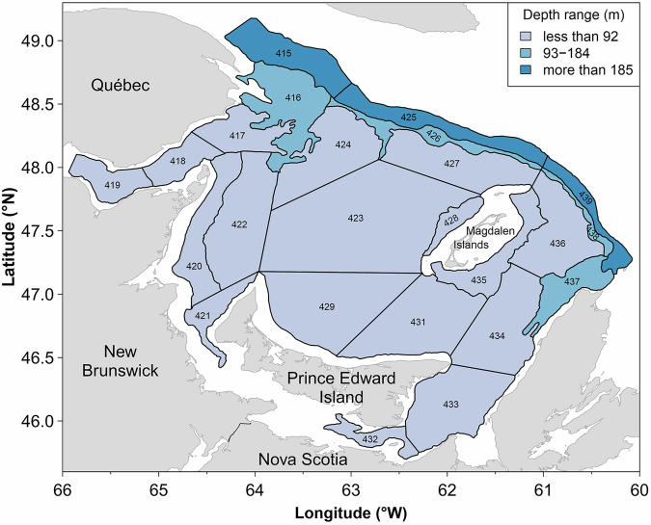
Figure 1. Study area. Bottom-trawl survey strata of the southern Gulf of St Lawrence (sGSL); numbers identify individual strata and their associated depth ranges. Reproduced from Burbank et al. (2025) under a CC BY 4.0 licence.

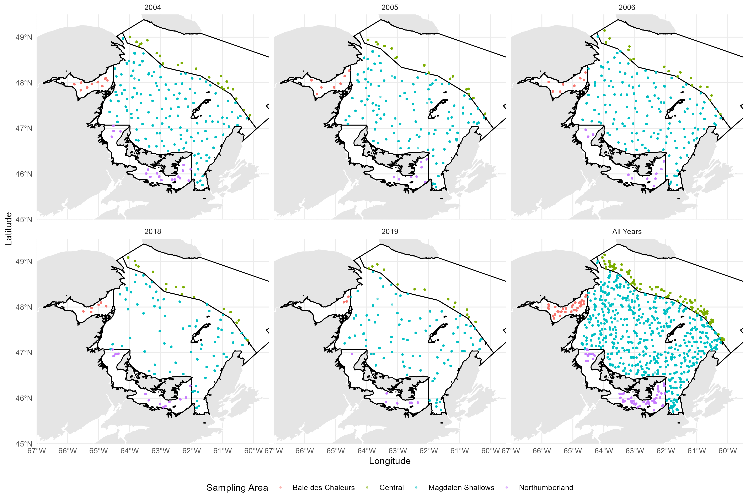
Figure 2. Spatial distribution of analysed predator stomachs by survey year across the sGSL in the 4 different ecoregions of the sGSL.

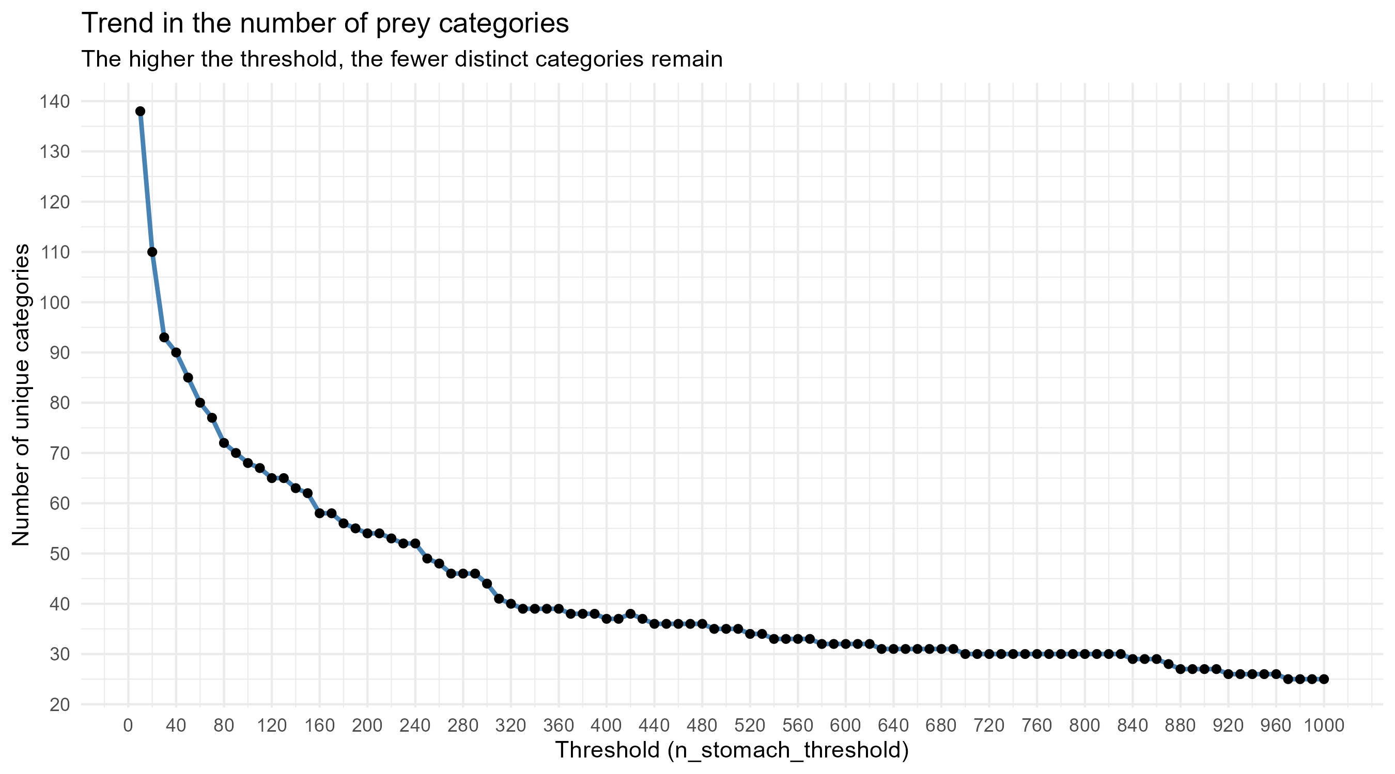
Figure 3. Trend in the number of prey categories: the higher the threshold, the fewer distinct categories remain. Sensitivity of the diagnostic outcome to prey taxonomic resolution. Family frequencies are shown as prey are progressively aggregated across ~100 resolution levels; the signal varies smoothly.

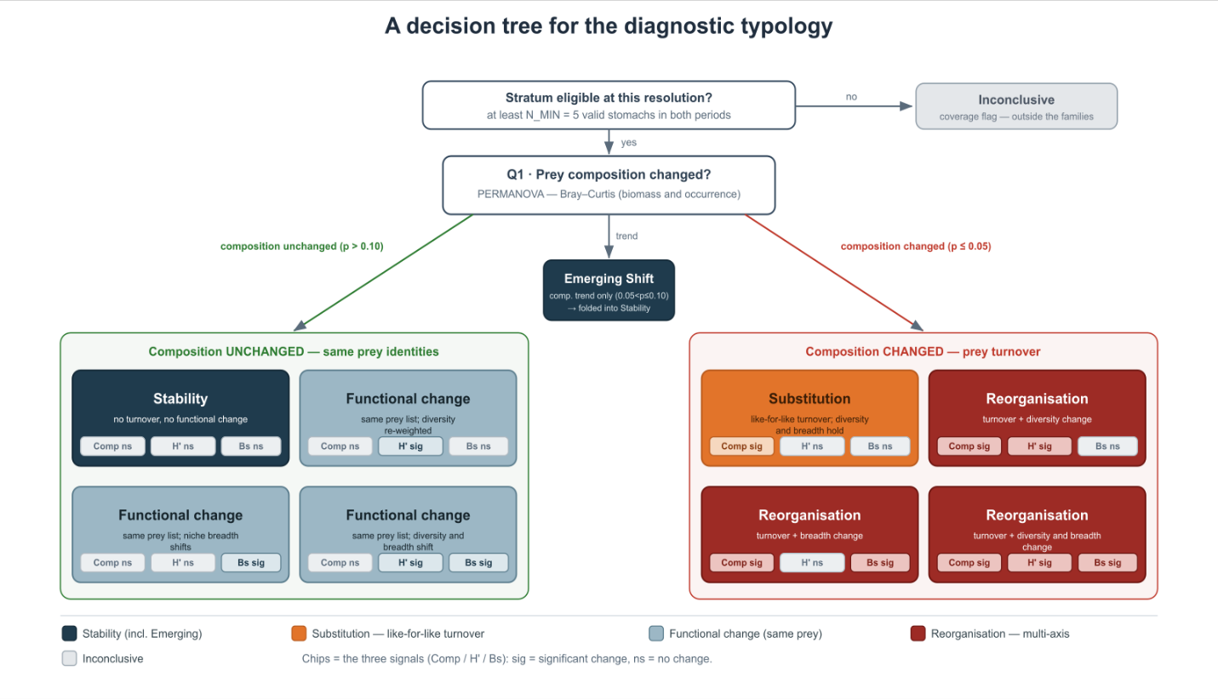
Figure 4. Decision tree for the diagnostic typology. Each eligible predator × prey-resolution cell is classified from three signals: prey composition (C; PERMANOVA on Bray-Curtis dissimilarity), Shannon diversity (H′; Hutcheson test) and standardised niche breadth (Bs; Levins index with bootstrap). Each signal was put into one of the four interpretive families: Stability, Functional change, Substitution and Reorganisation. Cells below the eligibility threshold (fewer than N_MIN valid stomachs in either period) are flagged Inconclusive and excluded. Chips indicate whether each signal changed significantly (sig) or not (ns); a composition trend only (0.05 < p ≤ 0.10) is folded into Stability.

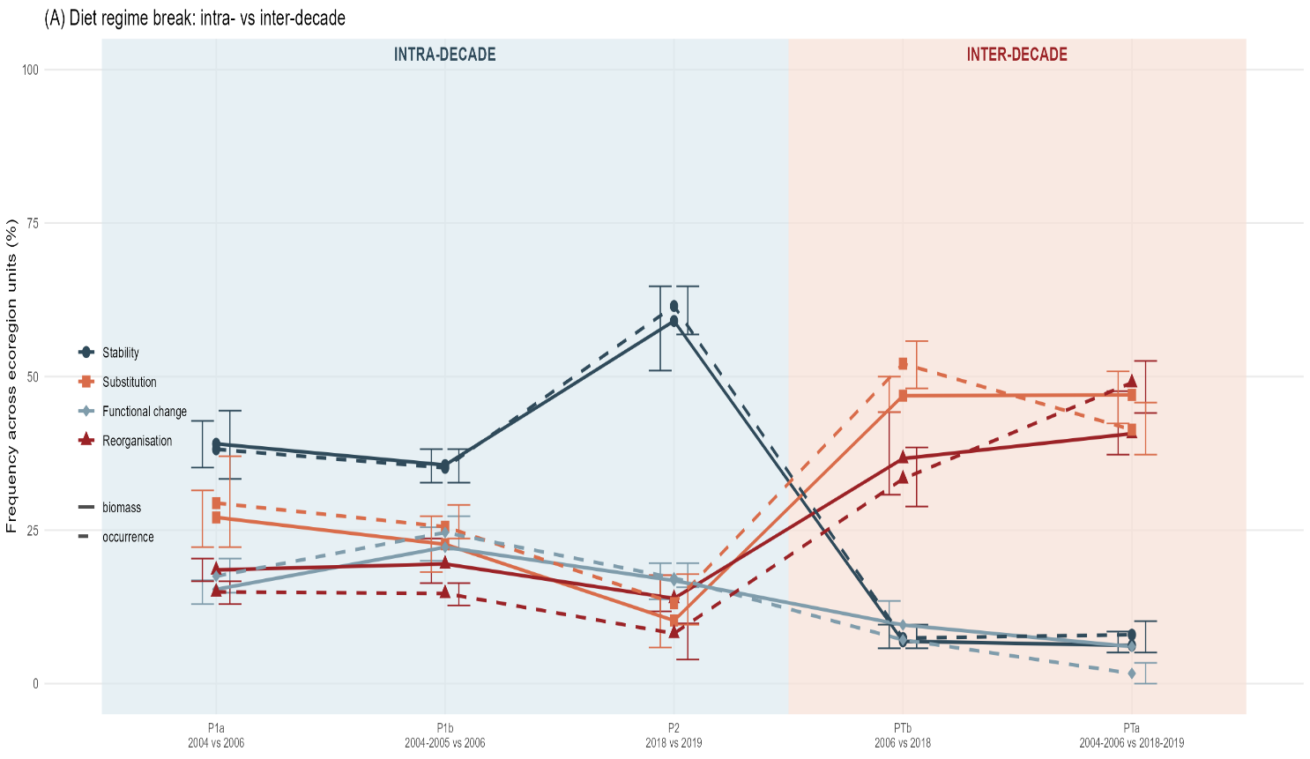
Figure 5. Diet regime break pooled for all of the sGSL. Mean family frequencies across strata for each contrast and currency reproduce, at the stratum scale, the pooled pattern of Figure 5: high Stability within decades and a shift toward Substitution between decades.

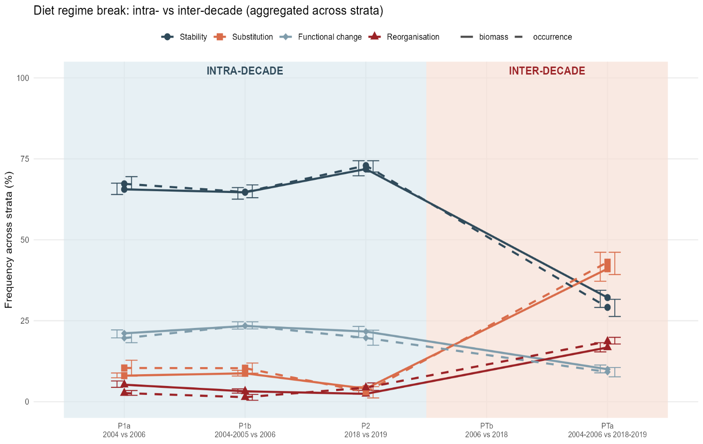
Figure 6. Diet regime break aggregated across survey strata. Mean family frequencies across strata for each contrast and currency reproduce, at the stratum scale, the pooled pattern of Figure 5: high Stability within decades and a shift toward Substitution between decades.
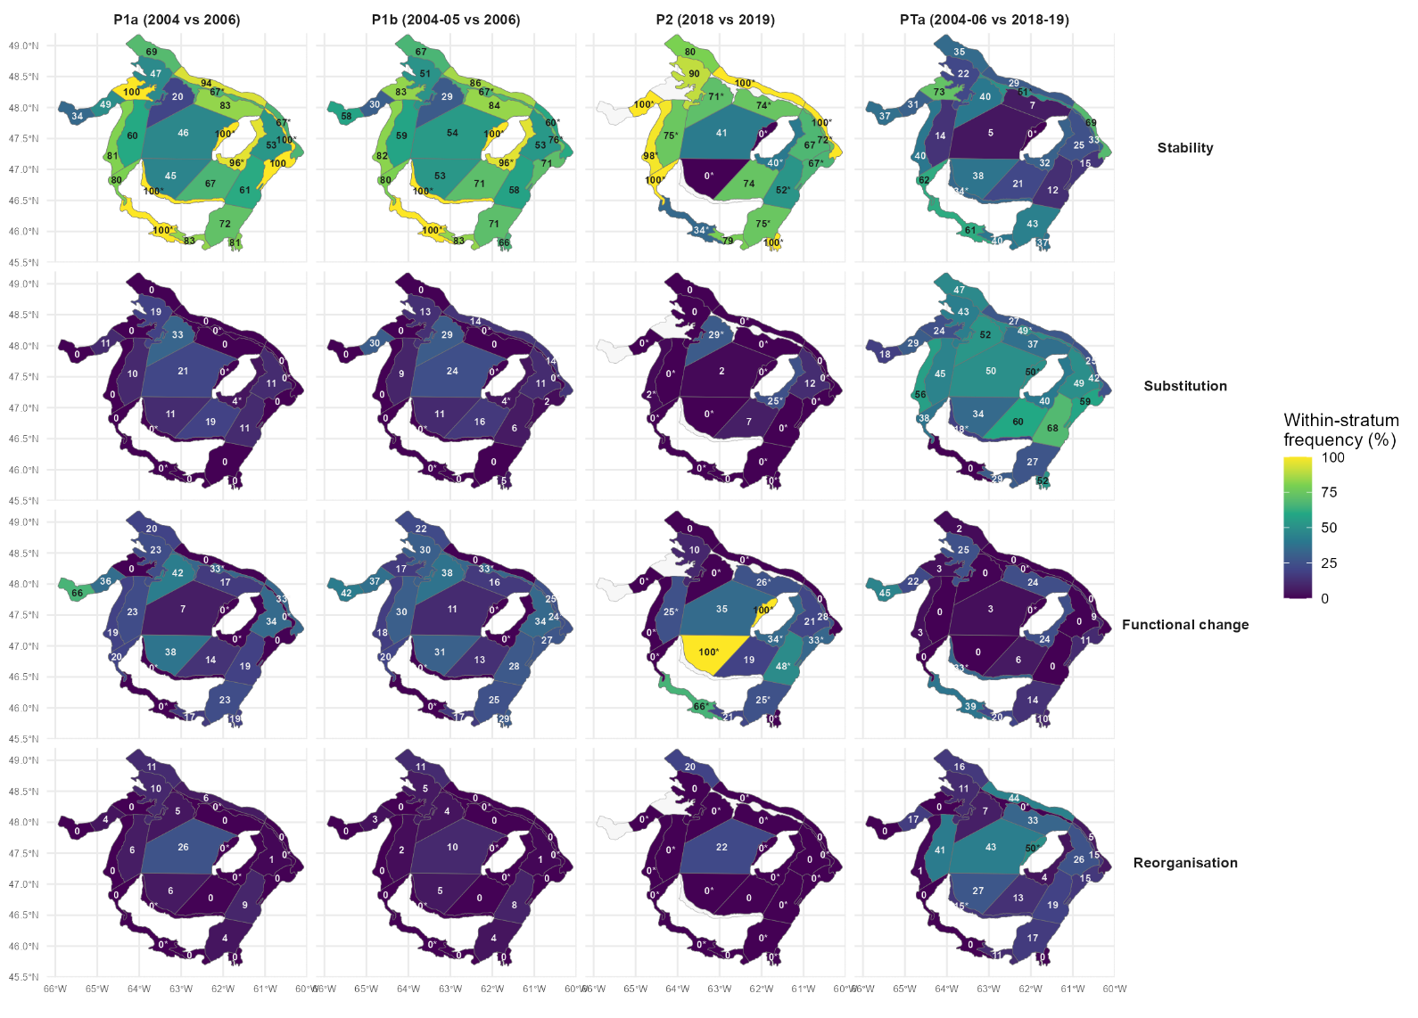
Figure 7. Spatial distribution of the four diet-regime families across survey strata, biomass currency. Each panel maps the within-stratum frequency (%) of one family (rows: Stability, Substitution, Functional change, Reorganisation) for one contrast (columns: P1a, P1b, P2, PTa). Fill colour and the printed value give the percentage; every stratum is shown, and values built on fewer than five predator × size-class units are marked with an asterisk (interpret with caution). The inter-decade robustness contrast PTb is not estimable at the stratum scale and is absent. Every stratum shown ; * = build on < 5predator x size_class units (interpret with caution). The occurrence-currency version and the version with flagged stratum with < 5 units are shown in Figure S[x].

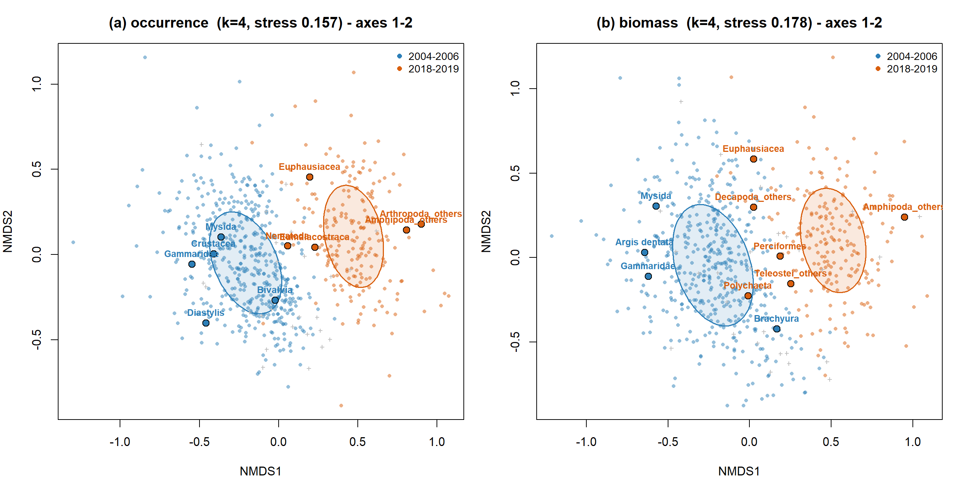
Figure 8. Non-metric multidimensional scaling (NMDS) of predator diets in the early (2004-2006) and recent (2018-2019) windows, for (a) occurrence and (b) biomass currencies. Separation between windows indicates compositional turnover; per-panel stress values are shown.

Tables
Table 1. The eight logical states of the typology, coded by composition (C), Shannon diversity (H′) and standardised niche breadth (Bs) as significant (1) or not (0), with the four interpretive families used throughout the Results.
State | C H B | Definition | Family | Interpretation
Stable Diet | 0 0 0 | Same prey, same evenness, same individual breadth. | Stability | No prey turnover and no functional change: diet stable in composition, evenness and individual breadth..
Internal Rebalancing | 0 1 0 | Prey shares are re-weighted while the prey set holds. | Functional change | Same prey set, but diet diversity and/or individual niche breadth shift.
Niche Compression / Expansion | 0 0 1 | Individuals specialise or generalise on the same prey. | Functional change
Niche Restructuring | 0 1 1 | Evenness and breadth both reorganise, same prey. | Functional change
Ghost Shift | 1 0 0 | Prey identities turn over, diet shape unchanged. | Substitution | Like-for-like prey turnover: prey identities change while diversity and breadth hold.
Partial Diet Shift | 1 1 0 | Turnover with a change in diversity. | Reorganisation | Prey turnover coupled with a change in diversity and/or niche breadth.
Structural Shift | 1 0 1 | Turnover with a change in niche breadth. | Reorganisation
Major Shift | 1 1 1 | Turnover on all three axes. | Reorganisation

Table 2. Multivariate tests on biomass-based diet composition. PERMANOVA (Bray-Curtis dissimilarity, 999 permutations) for the full model and for the period contrast at two pairing levels, with PERMDISP homogeneity-of-dispersion tests. Diet composition differs significantly between periods at every level. Multivariate dispersion is homogeneous at the analysis-cell level (the period effect is a genuine compositional shift), with some dispersion heterogeneity at the raw predator level.
Source | df | SS | R² (%) | F | p
PERMANOVA — composition ~ period × Area + size class (analysis cells, n = 758)
period | 1 | 17.20 | 7.4 | 65.93 | 0.001
Area | 3 | 8.45 | 3.7 | 10.80 | 0.001
size class | 2 | 6.93 | 3.0 | 13.29 | 0.001
period × Area | 3 | 3.30 | 1.4 | 4.21 | 0.001
Residual | 748 | 195.15 | 84.5
Total | 757 | 231.04 | 100
PERMANOVA — period only, cell-paired (blocked by cell, n = 306)
period | 1 | 7.97 | 8.0 | 26.38 | 0.001
Residual | 304 | 91.81 | 92.0
Total | 305 | 99.78 | 100
PERMANOVA — period only, predator level (n = 6014)
period | 1 | 105.13 | 4.0 | 252.66 | 0.001
Residual | 6012 | 2501.60 | 96.0
Total | 6013 | 2606.73 | 100
PERMDISP — multivariate dispersion between periods (homogeneity check)
Analysis-cell level (n = 758) | 1 | 0.005 |  | 0.52 | 0.471
Predator level (n = 6014) | 1 | 0.125 |  | 23.74 | <0.001

